Jerry Chen

CS 558

Computer Vision

Prof. Dunn

HW4

Output for part 1 of assignment (8 bins):

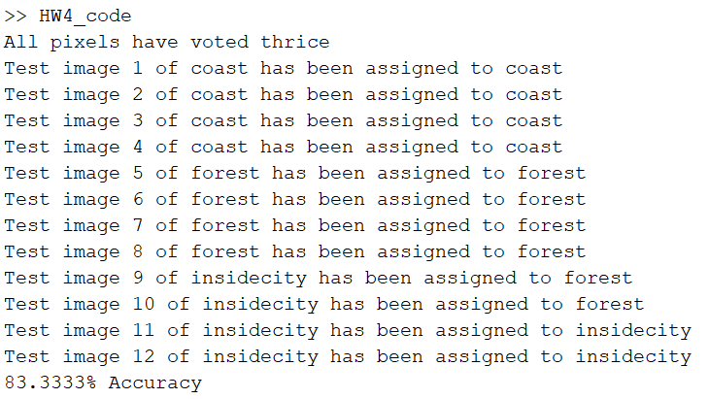

The highest accuracy that I was able to achieve is the 83% with eight and six bins. When I go higher or lower than that range the accuracy starts to decrease instead

Output with 16 bins:

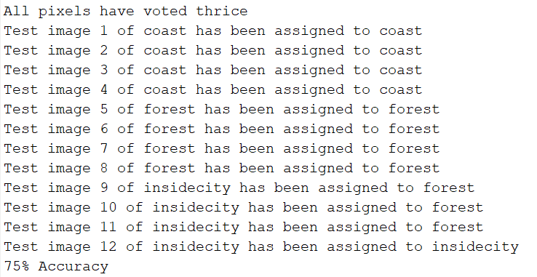

Output for part 2 of assignment:

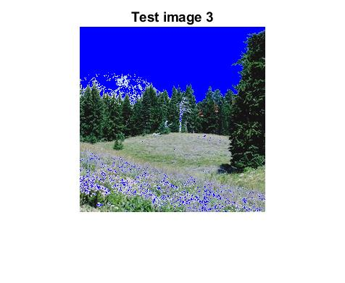

The sky classification generally works and finds the sky however because it is looking solely in the 3D space of rgb colors, all and only blue colored pixels are being counted as sky. This leaves out the white/gray clouds and picks up some other random blue objects such as the flowers in image 3. We could improve this by adding in the x and y dimensions to the algorithm so that it would be contained in positional regions and maybe increasing the value of k would also help.